ANALYSIS OF HYDROGEN GAS PRODUCTION RESULTS IN WATER ELECTROLYSIS PROCESS ON GENSET CHARACTERISTICS
D. H. Praswanto^{1*}, S. Djiwo², B. R. P. D. Palevi³
^{1,2,}Department of Mechanical Engineering, National Institute of Technology, Malang, Indonesia
⁴Departement of Electrical Engineering, National Institute of Technology, Malang, Indonesia
*Coresponding Author Email: djoko@lecturer.itn.ac.id

Abstract
Hydrogen gas is a type of alternative fuel for transportation that can serve a number of other potential needs. Water electrolysis is one way to get hydrogen gas. This study aims to determine the results of water electrolysis with three catalysts and mixed metal electrodes which are then applied to generator motor engines. The research method used was an experimental method with variations in electrolysis using KOH and NaOH base catalysts, H2SO4 acid catalysts, and stainless steel 316 electrodes. The best results for H2 gas production in this study were obtained with a 2M H2SO4 catalyst with a gas yield of 244.9mL H2 gas, while The lowest yield in this study was the 1M concentration of 1M NaOH catalyst of 12.5mL. The best results for H2 gas production were varied with pertalite fuel and then tested with a generator engine. Testing the generator motor engine is measured arm length and mass with a machine dynamometer. After testing, the data is obtained which is then analyzed to obtain the value of torque (Nm) and electric motor power (kW), and driving motor power (HP). The maximum energy produced pertalite + H2 gas has increased by 2.27kW on the electric motor and power of 4.13HP on the driving motor, while for pertalite fuel alone the power generated is 1.44kW on the electric motor and power of 2.62HP on the driving motor.

Keywords electrolysis, hydrogen gas, catalyst, generator, power
Paper type Research paper

Introduction
Renewable energy is generally opposed to fossil energy. Renewable energy sources are biomass, animat, solar, air, wind energy and geothermal energy. Fossil energy is found in coal, oil and natural gas (Agus 2017: 5). The main fuels that are often used in general are fuel oil (gasoline and diesel), electricity, and natural gas. Liquid fuel oil is commonly used in the transportation sector, while electricity and natural gas are used by buildings and other end users. In particular, the last few decades have seen significant research and development of electric-powered vehicles, including battery electric vehicles, hybrid electric vehicles and fuel cell hydrogen vehicles. Even though there has been a lot of activity in research and development, only a small portion of the use of transportation energy utilizes this alternative energy. Meanwhile, hydrogen is referred to as an alternative fuel for transportation that can serve a number of other potential needs.
Hydrogen potential development in the future can advance significantly and can change the energy system because there is a relationship between hydrogen and the electricity system. The unique characteristics of electricity and its long history of converting primary energy sources such as fossil fuels, nuclear energy and renewable energy sources into electricity. Hydrogen gas is obtained by carrying out several processes, one of which is by using the water electrolysis process. Water electrolysis is the event of decomposition of water compounds (H2O) into hydrogen gas (H2) and oxygen (O2) using an electric current through the water. H2 gas has the potential to be used as energy because it is environmentally friendly. H2 gas provides an emission level close to zero emission.
The process of electrolysis in decomposing water compounds takes place slowly so it requires a catalyst to speed up the reaction and can increase the amount of hydrogen gas produced. In the process of electrolysis occurs when the flow of electric current flows through ionic compounds and reacts after passing through an electrolyte solution assisted by a catalyst. This happens because the electrolyte solution contains ions that can move freely after direct current flows. The water electrolysis process that produces H2 gas can be used to reduce the use of fossil fuels and reduce air pollution and greenhouse gas emissions, so alternative energy production such as hydrogen gas must be maximized.
Water electrolysis is the process of decomposing water compounds (H2O) into oxygen (O2) and hydrogen gas (H2) using an electric current through the water. In the water electrolysis process, water can be ionized into H2 and O2 in the presence of a large energy flow. By using the usual electrolysis method, only 4% of the production of hydrogen from pure water requires an electrolyte solution to maximize production.
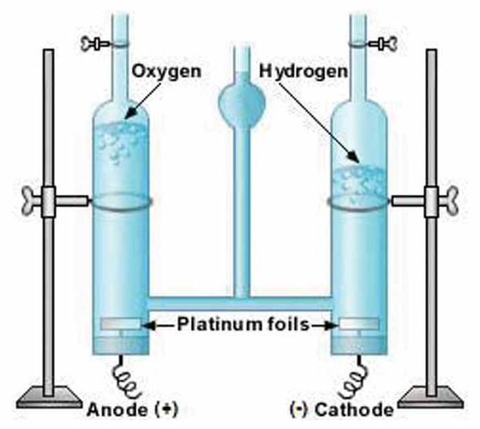
Figure 1. water electrolysis process
Water electrolysis is the process of decomposing water compounds (H2O) into oxygen (O2) and hydrogen gas (H2) using an electric current through the water. In the water electrolysis process, water can be ionized into H2 and O2 in the presence of a large energy flow. Using the usual electrolysis method, only 4% yields p. At the cathode, two water molecules react by gaining two electrons, being reduced to H2 gas and hydroxide ions (OH-). Meanwhile at the anode, two other water molecules break down into oxygen gas (O2), releasing 4 H+ ions and flowing electrons to the cathode. H+ and OH- ions undergo neutralization so that several water molecules are formed again (Rijal et al, 2015).
The factors that affect the yield of hydrogen production in the electrolysis process include the following:
- Quality of electrolyte
- Electrolytic resistance
- Temperature
- Pressure
- The type of catalyst used
- Type of electrode material
Hydrogen production from pure water requires an electrolyte solution to maximize production. A catalyst is a substance that speeds up the rate of a chemical reaction at a certain temperature, without being changed or used up by the reaction itself. A catalyst plays a role in the reaction but not as a reactant or product. Catalysts allow it to proceed more quickly or allow it to occur at lower temperatures due to the changes it induces in the reactants. The catalyst provides an alternative pathway with a lower activation energy. Catalyst reduced energy needed for reaction.
Compounds such as acids, bases, and salts that can conduct electric current can be used in the electrolysis process. The presence of ions in solution causes conduction events and when an electric current is passed through the solution, electrons will move between the ions. As a catalyst H2SO4 (acid) functions to accelerate the decomposition of water into hydrogen because the catalyst ions can affect the balance of water molecules into H+ and OH- ions which are easier to electrolyze due to a decrease in activating energy.

Method
In water electrolysis, electrical energy is obtained from DC power that flows through cables connected to the electrodes. Compound water (H2O) which is electrified, it will react and break down into oxygen (O2) and hydrogen gas (H2). To speed up the decomposition process, a catalyst solution will be added to the electrolysis vessel to accelerate the decomposition. After the H2O decomposes, the hydrogen gas that has been produced will be put into a tube which will later produce hydrogen gas whose volume will be measured.

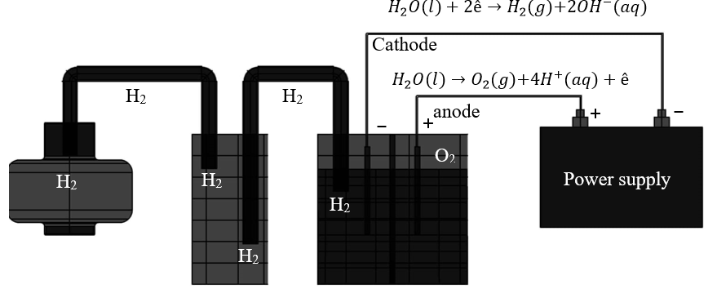
Figure 3. Water Electrolysis Work System
In the implementation of this research carried out with the following steps.
- Determining the variables that are carried out, namely everything that will be the object of observation in any form of research so that later it is determined to be studied so that information can be obtained from the test. Here are the variables used. Varying the concentration of the catalyst to be used varies KOH 1M, 2M and 4M then NaOH 1M, 2M and 4M and finally H2SO4 1M, 2M and 4M which will be mixed with water (H2O).
- Independent variable
Using a mixture of catalyst concentrations (KOH catalyst with concentrations of 1M, 2M and 4M; NaOH catalyst with contrasts of 1M, 2M and 4M; H2SO4 catalyst with concentrations of 1M, 2M and 4M).
- Dependent variable
Water (H2O) as the electrolyzed material and the SS316 electrode which is electrified.
- Controlled variable
The time used in this electrolysis process is 5 minutes, 10 minutes, and 15 minutes.
- Test the electrolysis device to determine the strength of the current flowing during the electrolysis of water by holding the electrolysis time of 5 minutes, 10 minutes and 15 minutes to determine the results of the gas produced.
- Retrieval of test results data, namely observing the test object and recording the data generated by the tool test.
- Data processing, namely the data that has been obtained is then arranged to be more perfect or processed according to what is needed. Data processing is made in tables, in this thesis research the data obtained from testing includes:
- the yield of hydrogen gas,
- electric current, and
- generator characteristics.
- Discussion, data analysis is carried out on the results obtained from the research and discussed based on existing literature studies.
- Conclusion, the tests that have been analyzed and discussed are then summarized in conclusions.

Discussion
Production of Electrolyzed Hydrogen Gas with a Catalyst
Comparison of the results of the volume of H2 gas produced at each catalyst concentration mixed during the water electrolysis process results as follows.
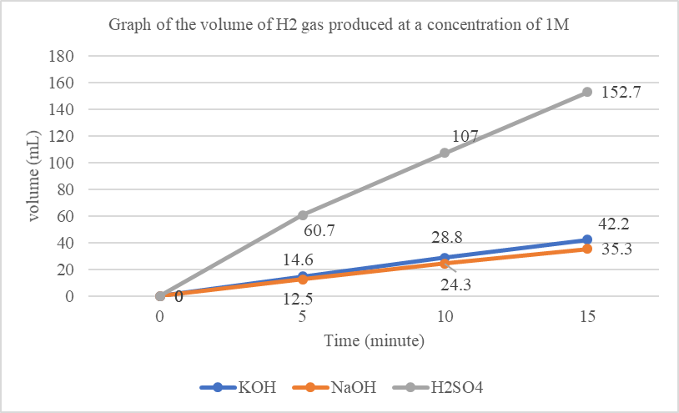
Figure 4. Graph of the volume of H2 gas produced from the electrolysis of water with a catalyst concentration of 1M
Figure 4 shows a comparison of the yield of H2 gas when using a catalyst concentration of 1M. The best H2 gas production results were obtained when using an H2SO4 catalyst of 152.7 mL. In the use of NaOH catalyst, the lowest yield is 12.5 mL.
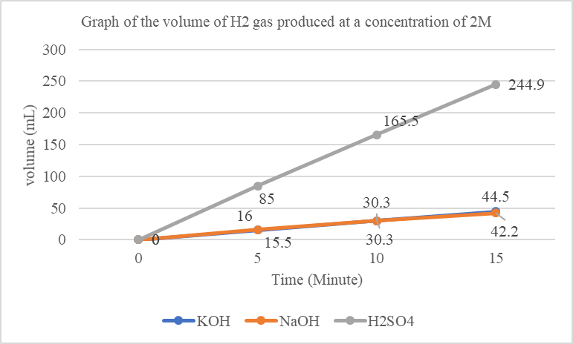
Figure 5. Graph of the volume of H2 gas produced from the electrolysis of water with a catalyst concentration of 2M
Figure 5 shows a comparison of the yield of H2 gas when using a catalyst concentration of 2M. The best H2 gas production results were obtained when using an H2SO4 catalyst of 244.9 mL. In the use of KOH catalyst, the lowest yield was 15.5 mL.
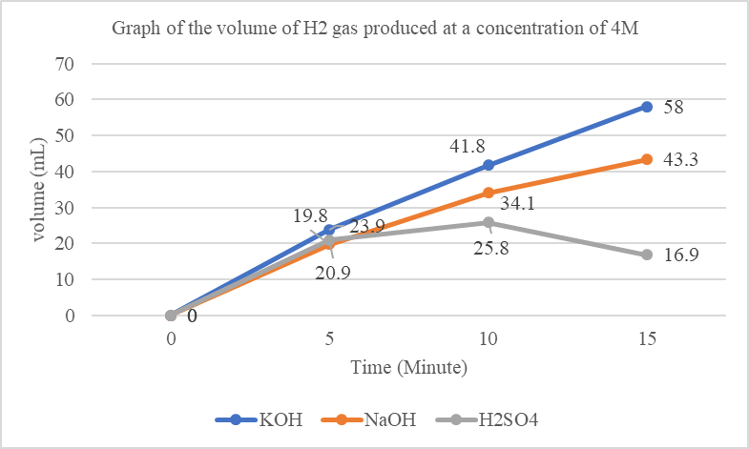
Figure 6. Graph of the volume of H2 gas produced from the electrolysis of water with a catalyst concentration of 4M
Figure 6 shows a comparison of the yield of H2 gas when using a catalyst concentration of 4M. The best H2 gas production results were obtained when using a KOH catalyst of 58 mL. Using the H2SO4 catalyst, the lowest yield was 16.9 mL.
Characteristics of the use of mixed hydrogen fuel
Based on the data obtained from the test results on the ET 1500L gasoline generator using pure pertalite fuel and testing using pertalite fuel added with H2 gas in the intake manifold, each use of fuel has its own characteristics. When using pertalite fuel, added H2 gas which is injected into the intake manifold has a better torque than using pure pertalite fuel. Other characteristics can be seen in table 1 as follows:
Table 1 Comparison of fuel use
Information | Pertalite 100% | Pertalite + H₂
Loads that can be received at a speed of 300Rpm | 2.6 Kg | 4.105 Kg
generated torque | 4.59 Nm | 7.24 Nm
Electric Motor Power | 1.44 kW | 2.27 kW
Drive Motor Power | 2.62 HP | 4.13 HP

Based on table 1, a graph of the characteristics of the ET 1500L gasoline generator can be made to determine the increase in the characteristics of the generator as follows:
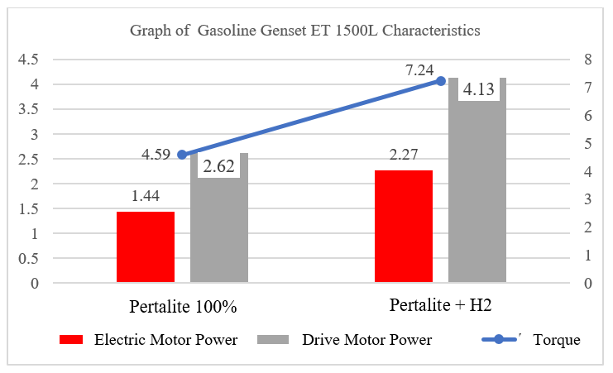
Figure 7. Gasoline Genset ET 1500L Characteristics
Figure 7 shows that the characteristics of the ET 1500L gasoline generator experienced an increase in characteristics after adding H2 gas which was injected into the intake manifold. The characteristics obtained are better than using pure pertalite fuel, both in terms of torque values, electric motor power and driving motor power.

Conclusion
The use of a catalyst as an increase in production results is in accordance with the theory of electrolysis of water with a mixture of catalysts. In this experiment, the best results were obtained using a mixture of strong acid solutions, namely at a concentration of 2M of 244.9 mL for 15 minutes. The H2SO4 solution contains sulfate anions which cannot be electrolyzed so that when electrolyzed water is used as the solvent, so that more H2 gas is produced. However, in the H2SO4 solution, the higher the concentration of the solution, the lower the production of H2 gas due to the large number of sulfate anions that cannot be electrolyzed, thereby inhibiting the electrolysis of water. The characteristics of the ET 1500 Gasolin generator motor which uses pertalite fuel and is mixed or injected with hydrogen gas in the intake manifold has increased compared to using pure pertalite. Evidenced by the electric motor power produced pertalite + H2 gas has increased by 2.27 kW and the power of the driving motor is 4.13 HP while for pertalite fuel alone the electric motor power produced is 1.44 kW and the driving motor power is 2.62 HP.

Acknowledgment
Thank you very much to the Ministry of Finance's Education Fund Management Institution (LPDP) for funding research through the rispro program and the Ministry of Education and Culture Research Technology so that our team was able to complete and publish research results.

References
[1] M. Wróbel‐jędrzejewska and E. Polak, “The operation analysis of the innovative mainbox food storage device,” Appl. Sci., vol. 11, no. 16, 2021, doi: 10.3390/app11167682.
[2] B. Ekumah et al., “Disparate on-site access to water, sanitation, and food storage heighten the risk of COVID-19 spread in Sub-Saharan Africa,” Environ. Res., vol. 189, p. 109936, 2020, doi: 10.1016/j.envres.2020.109936.
[3] Ontario. Ministry of Health and Long-Term Care. Medical Advisory Secretariat., “Air cleaning technologies : health technology literature review.,” Ont Heal. Technol Assess Ser. 2005; 5(17) 1–52. , vol. 5, no. 17, pp. 1–52, 2005.
[4] W. C. Y. M. L. P. R. V. P. A. R. S. M. P. David A. Christopherson, “High-Efficiency Particulate Air Filters in the Era of COVID-19: Function and Efficacy | Enhanced Reader,” American Academy Otolaryngology–Head and Neck Surgery, 2020. .
[5] F. Uddin, N. Gunde-cimerman, and F. Uddin, “Environmental Concerns in Antimicrobial Finishing of Textiles Related papers Environmental Concerns in Antimicrobial Finishing of Textiles,” doi: 10.5923/s.textile.201401.03.
[6] K. J. Edgar and H. Zhang, “Antibacterial modification of Lyocell fiber: A review,” Carbohydr. Polym., vol. 250, p. 116932, 2020, doi: 10.1016/j.carbpol.2020.116932.
[7] J. Nsor-Atindana, F. Zhong, K. J. Mothibe, M. L. Bangoura, and C. Lagnika, “Quantification of total polyphenolic content and antimicrobial activity of cocoa (Theobroma cacao L.) Bean shells,” Pakistan J. Nutr., vol. 11, no. 7, pp. 574–579, 2012, doi: 10.3923/pjn.2012.672.677.
[8] T. Horikawa, Y. Kitakaze, T. Sekida, J. Hayashi, and M. Katoh, “Characteristics and humidity control capacity of activated carbon from bamboo,” Bioresour. Technol., vol. 101, no. 11, pp. 3964–3969, 2010, doi: 10.1016/j.biortech.2010.01.032.
[9] D. Krans, “(12) Patent Application Publication (10) Pub. No.: US 2014/0186224 A1,” vol. 1, no. 19, 2014.
[10] L. M. Ferreira, R. R. de Melo, A. S. Pimenta, T. K. B. de Azevedo, and C. B. de Souza, “Adsorption performance of activated charcoal from castor seed cake prepared by chemical activation with phosphoric acid,” Biomass Convers. Biorefinery, 2020, doi: 10.1007/s13399-020-00660-x.
[11] J. Jimmy, A. Roesyadi, S. Suprapto, F. Kurniawansyah, W. Anggraini, and R. Rahmawati, “Activated carbon from bamboo waste: Effect of activation sequences and iron-cobalt impregnation to material properties and catalyst performance,” J. Appl. Eng. Sci., vol. 18, no. 1, pp. 1–9, 2020, doi: 10.5937/jaes18-23014.
[12] A. Staszowska, “Assessment of the air purifier effectiveness under model conditions,” J. Phys. Conf. Ser., vol. 1736, no. 1, 2021, doi: 10.1088/1742-6596/1736/1/012043.
[13] B. Joseph Oso, A. Oluwaseun Adeoye, and I. Francis Olaoye, “Pharmacoinformatics and hypothetical studies on allicin, curcumin, and gingerol as potential candidates against COVID-19-associated proteases,” J. Biomol. Struct. Dyn., pp. 2–13, 2020, doi: 10.1080/07391102.2020.1813630.
[14] M. Musarra-pizzo, R. Pennisi, I. Ben-amor, G. Mandalari, and M. T. Sciortino, “Human Viruses,” pp. 1–30, 2021.
[15] M. Firoozi, S. Rezapour-Jahani, Z. Shahvegharasl, and N. Anarjan, “Ginger essential oil nanoemulsions: Preparation and physicochemical characterization and antibacterial activities evaluation,” J. Food Process Eng., vol. 43, no. 8, 2020, doi: 10.1111/jfpe.13434.
[16] X. Wang et al., “Antibacterial Activity and Mechanism of Ginger Essential Oil against Escherichia coli and Staphylococcus aureus,” Molecules, vol. 25, no. 17, 2020, doi: 10.3390/molecules25173955.
[17] M. Karnib, A. Kabbani, H. Holail, and Z. Olama, “Heavy metals removal using activated carbon, silica and silica activated carbon composite,” Energy Procedia, vol. 50, pp. 113–120, 2014, doi: 10.1016/j.egypro.2014.06.014.
[18] U. Kouakou, A. S. Ello, J. A. Yapo, and A. Trokourey, “Adsorption of iron and zinc on commercial activated carbon,” J. Environ. Chem. Ecotoxicol., vol. 5, no. 6, pp. 168–171, 2013, doi: 10.5897/JECE2013.0264.
[19] V. C. Srivastava, I. D. Mall, and I. M. Mishra, “Adsorption of toxic metal ions onto activated carbon. Study of sorption behaviour through characterization and kinetics,” Chem. Eng. Process. Process Intensif., vol. 47, no. 8, pp. 1269–1280, 2008, doi: 10.1016/j.cep.2007.04.006.
[20] R. Isticato, M. Lanzilli, C. Petrillo, G. Donadio, L. Baccigalupi, and E. Ricca, “Bacillus subtilis builds structurally and functionally different spores in response to the temperature of growth,” Environ. Microbiol., vol. 22, no. 1, pp. 170–182, 2020, doi: 10.1111/1462-2920.14835.
[21] K. V. Sazanova et al., “Carbonate and oxalate crystallization by interaction of calcite marble with bacillus subtilis and bacillus subtilis–aspergillus niger association,” Crystals, vol. 10, no. 9, pp. 1–16, 2020, doi: 10.3390/cryst10090756.
[22] M. Duan et al., “Effects of Bacillus subtilis on carbon components and microbial functional metabolism during cow manure–straw composting,” Bioresour. Technol., vol. 303, no. January, p. 122868, 2020, doi: 10.1016/j.biortech.2020.122868.

