**STUDY OF CHARACTERISTICS OF USED TIRE, ASPHALT, AND *RHDPE* POWDER COMPOSITESAS CAR**

**FENDER MATERIAL**

***Anwar Nurharyanto1 , Wachid Yahya2***

*1,2Bachelor of Applied Automotive Engineering Technology, Polytechnic Indonusa Surakarta*

[*anwar.nurharyanto@poltekindonusa.ac.id*](mailto:anwar.nurharyanto@poltekindonusa.ac.id) *,* [*wachidyahya@poltekindonusa.ac.id*](mailto:wachidyahya@poltekindonusa.ac.id)

*Submitted :* ; *Revision :* ; *Accepted :*

***Abstract***

This research aims to determine the effect of composition on used tire powder composites, asphalt, and recycled plastic *(rHDPE),* on tensile stress. The composite is expected Can be used for fenders on cars. The composition variations in this study were 500 grams of used tire powder, and 100 grams of asphalt, with variations of *rHDPE* 20, 30, 40, 50, 60, 70, 80, 90, 100, 120, 200, 250, 300, 350, 400 grams. From the tensile test results, the lowest tensile stress was obtained 0.0233 N/mm2 is owned by a composite with a composition of 40-gram *rHDPE.* For tensile stress. The highest was a composite with a composition of 400-gram *rHDPE* with a tensile stress value of 0.855 N/ mm2. The tensile test results of factory-made car *fenders* have a tensile stress of 0.852 N/mm2. From this research, it can be concluded that composites with composition High rHDPE can be used for *fenders.*

Keywords: Composite, rHDPE, tensile stress

**Paper type** Research paper

**Introduction**

Advances in science and technology in recent years have increasingly developed rapidly so that they can change a person's life structure [1]. The results were very positive viz the discovery of technologies that can make a person's life easier by increasingly complex needs. The volume of polymer waste such as tire rubber and bottles of *polyethylene terephthalate (PET)* is increasing at a rapid rate. An estimated 1000,000,000 tires reach the end of their useful life every year and 5000 million more[2] are expected to be disposed of periodically by 2030[3]. One of the main challenges that humans have to face today is the enormous amount of waste that has negative impacts on the environment[4]. One way that is environmentally friendly and feasible is recycling, by using it as a second raw material for new value-added products. By this, "all waste" composite with *rubber-polyethylene terephthalate (PET) - density polyethylene (HDPE)[5].*

Composites play a very important role in the automotive sector because they have properties such as stiffness height, lightweight, and high strength [6]. Basically, a composite material is a mixture of two or more components. Advanced composites have a history long, starting from the aerospace industry in the 1970s, but currently, composites are used in all industrial fields[7]. In developed countries, natural ecosystems increasingly place the burden on manufacturers to consider the ecological impact of products [8].

In the research, used tire powder, asphalt, and recycled plastic *(rHDPE)* will be processed into a composite. In the future, these composites can be used to replace the role of polymers as car fender material. Because factory fenders are easily torn and brittle if exposed to water. High temperatures are also expensive. Until now no material has been found replacement for the factory fender so that its use is still maintained. Expected composite This recycled raw material can replace the role of factory fenders.

**Method**

**Research Methods**

A research method is a research design that provides direction for research so that the necessary data can be collected. The research used an experimental method which was carried out by determining the effect of composite composition with used tire powder, asphalt, and *rHDPE* which would compare its tensile strength with factory-made fenders*Type sizes and typefaces:*

**Tensile Test Method**

We can find out the mechanical properties of a material by testing the material. In this research, to determine the strength value of a composite, a tensile test was carried out. For polymer composite materials, tensile testing uses testing to the ASTM D638 Type I standard with test object dimensions as in Figure 1 and Table 1 below [9].

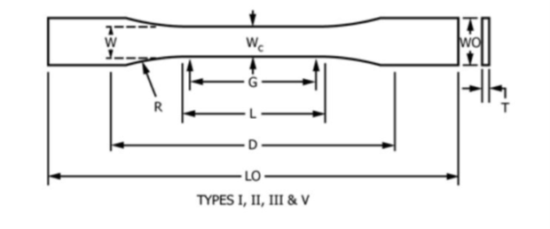

Figure 1. Tensile Test Specimen

To determine the tensile stress of a material, you can use mathematical calculations as below:

Tension *(Stress)*:  σ = F/A

Where :

F = pulling force

A = cross-sectional area

Strain:  ε  = ΔL/L

Where :

ΔL = increase in length

L = initial length

The relationship between stress and strain can be formulated :

E = σ / ε

Where :

E = modulus of elasticity

**Reasearch Flow Diagram**

Measuring Composition

Preparation

Material

Tool

Making Composition

Mixing

Pressing Specimen

Testing

Tensile Test

Micro Photo

Conclusion

Figure 2. Research flow diagram

**Research Materials**

The research materials used in this research are

**Recycled HDPE (High-Density Polyethylene)**

HDPE is *High-Density Polyethylene* – a tough, strong, and stiff resin derived from oilearth, which is often formed by blowing it[10]. *Recycled* HDPE is obtained from the factory plastic pellet producer in the Solo area. The *HDPE* plastic used in this research is type*HDPE* is a result of recycling engine oil bottles in the form of small tubes with a length of 2 mmand a diameter of 1 mm. The shape of *the rHDPE* plastic pellets is shown in Figure 3.

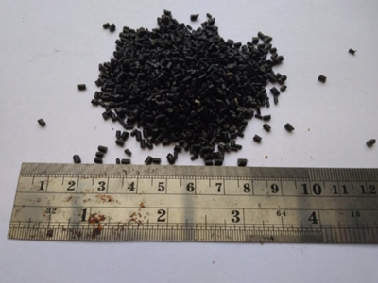

Figure 3. *rHDPE* Plastic Seed

**Filed Tire Powder**

The tire powder used in this research was obtained from the process of grinding car tires which will be *vulcanized.* To determine the size of used tire powder, this is done first sieving so that a powder size of 6 – 7 *mesh can be determined.* Formed from used tire powder shown in Figure 4.

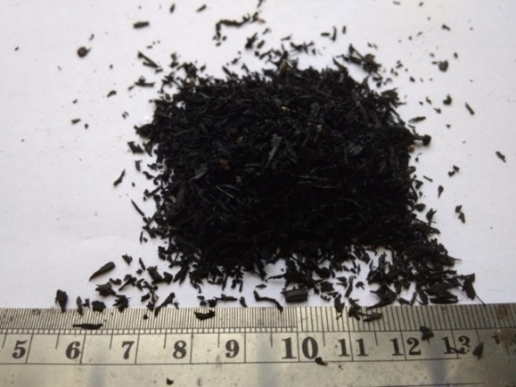

Figure 4. Used Tire Powder

**Asphalt**

The type of asphalt used in this research is solid asphalt from the DPU (Public Works Department) which is used for highways. The form of asphalt can be seen in Figure 5.

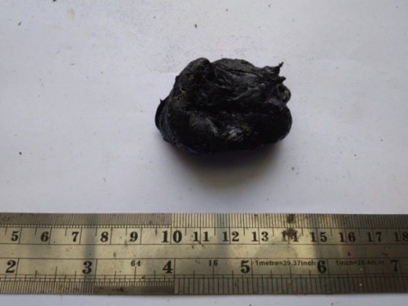

Figure 5. Solid Asphalt

**Composite Composition**

The first step in making specimens begins with weighing the used tire powder weighing 500 grams, 15 pieces. Weigh asphalt weighing 100 grams as much as 15 pieces, and *rHDPE* plastic seeds weighing 20, 30, 40, 50, 60, 70, 80, 90, 100, respectively 120, 200, 250, 300, 350, 400 grams as shown in Table 2.

Table 2. Composite Mixture Composition

|  |  |  |  |
| --- | --- | --- | --- |
| **No** | **Used Tire *(gram)*** | **Asphalt *(gram)*** | ***rHDPE* *(gram)*** |
| 1 | 500 | 100 | 20 |
| 2 | 500 | 100 | 30 |
| 3 | 500 | 100 | 40 |
| 4 | 500 | 100 | 50 |
| 5 | 500 | 100 | 60 |
| 6 | 500 | 100 | 70 |
| 7 | 500 | 100 | 80 |
| 8 | 500 | 100 | 90 |
| 9 | 500 | 100 | 100 |
| 10 | 500 | 100 | 120 |
| 11 | 500 | 100 | 200 |
| 12 | 500 | 100 | 250 |
| 13 | 500 | 100 | 300 |
| 14 | 500 | 100 | 350 |
| 15 | 500 | 100 | 400 |

**Discussion**

**Tensile Test**

After carrying out the tensile test, the results of the tensile stress values are obtained as in Table 1. Two workpieces cannot be read by the test equipment, namely variations in rHDPE weight 20 and 30 grams, this is because the composite is very soft. The lowest tensile strength occurs in composites with variations in rHHPE weight of 40 grams with a tensile stress value of 0.1332 N/mm2. The highest tensile stress value is owned by the 400-gram *rHDPE* variation of 0.855 N/mm2. The tensile test results can be seen in Table 3. Below.

|  |  |  |  |  |
| --- | --- | --- | --- | --- |
| **No** | **Used Tire *(gram)*** | **Asphalt *(gram)*** | ***rHDPE* *(gram)*** | ***σ N/mm2*** |
| 1 | 500 | 100 | 20 | Can’t be read |
| 2 | 500 | 100 | 30 | Can’t be read |
| 3 | 500 | 100 | 40 | 0,0233 |
| 4 | 500 | 100 | 50 | 0,0367 |
| 5 | 500 | 100 | 60 | 0,0497 |
| 6 | 500 | 100 | 70 | 0,0506 |
| 7 | 500 | 100 | 80 | 0,0560 |
| 8 | 500 | 100 | 90 | 0,0683 |
| 9 | 500 | 100 | 100 | 0,0906 |
| 10 | 500 | 100 | 120 | 0,1332 |
| 11 | 500 | 100 | 200 | 0,2441 |
| 12 | 500 | 100 | 250 | 0,3600 |
| 13 | 500 | 100 | 300 | 0,6521 |
| 14 | 500 | 100 | 350 | 0,7231 |
| 15 | 500 | 100 | 400 | 0,8550 |

**Comparison of Composite Tensile Stress Values with Factory Fenders**

The results of the manufacturer's fender tensile test show a tensile stress value of 0.861 N/mm2. Thus, the composite with a variation of 400-gram rHDPE has a tensile stress value equal to the factory fender tensile stress.



Figure 6. Stress and strain variation curves for a mixture of 500 grams of used tire powder, 100 grams of asphalt, and 400 grams *of rHDPE*

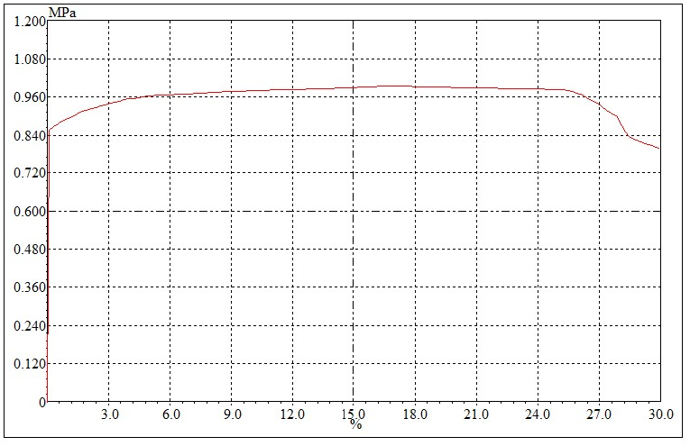

Figure 7. Manufactured fender stress and strain curves

**Micro Photo Test**

The results of the microphotographs can be seen that the composite with a low rHDPE composition. The structure is dominated by asphalt and used tire powder, causing stress the pull is low. Because the physical nature of the composite is soft

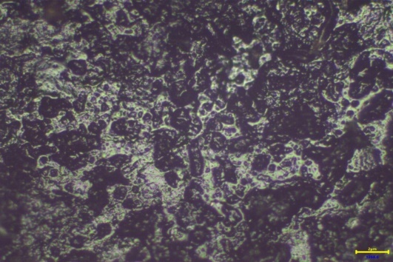

Figure 8. Micro-micro photo of variations of 500 grams of used tire powder, 100 grams of asphalt, 20 grams *of rHDPE* with a magnification of 100

This is different from specimens that have a high *rHDPE* content, from the results of microphotographs In these specimens, asphalt no longer dominates. It can be seen that the three compositions are starting to even out to all parts of the workpiece. From this, we can see that *rHDPE* plays a role in reinforcement in the specimen

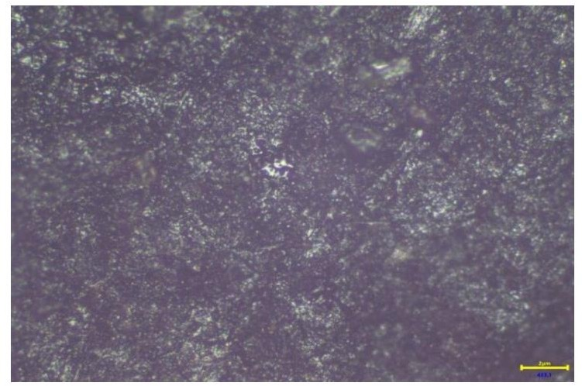

Figure 9. Photo of micro micro variations of 500 grams of used tire powder, 100 grams of asphalt, 400 grams *rHDPE* with 100 X magnification.

**Conclusion**

From the results of the research and data analysis that has been carried out, conclusions can be drawn, including the following:

1. Composites with low rHDPE composition have low tensile stress values low.
2. Composites with a high rHDPE composition have tensile stress values tall.
3. The rHDPE content affects the tensile stress.
4. Composite containing 500 grams of asphalt, 100 grams of tire powder, and 400 grams of rHDPE, the tensile stress is the same as the tensile stress of factory-produced fenders.
5. A composite of asphalt, tire powder, and rHDPE with a composition of 400 grams of rHDPE can be used as fender material for cars.

**Acknowledgment**

We would like to thank the Leadership, UPPM, fellow lecturers, and students of Politeknik Indonusa Surakarta who have facilitated and assisted in carrying out the research so that this research was completed.

**References**

1. R. Christu Paul, B. Ramachandran, G. Sushma, KH Aditya Harshavardhan, and I. Rohith, "An empirical research on areca fiber polymer composite for automotive components in modern industry," *Mater. Today Proc.,* vol. 33, no. xxxx, pp. 4493–4497, 2020, doi: 10.1016/j.matpr.2020.07.715.
2. N. Murugu Nachippan, M. Alphonse, VK Bupesh Raja, S. Shasidhar, G. Varun Teja, and R. Harinath Reddy, “Experimental investigation of hemp fiber hybrid composite material for automotive applications,” *Mater. Today Proc.,* vol. 44, no. xxxx, pp. 3666–3672, 2021, doi: 10.1016/j.matpr.2020.10.798. CH Manideep and E. Raja, “Analysis and Optimization of Composite Propeller Shaft for Automotive Applications,” *J. Phys. Conf. Ser.,* vol. 2272, no. 1, 2022, doi: 10.1088/1742- 6596/2272/1/012027.
3. W.T. Ouazzani, L. El Farissi, E. Monteiro, and A. Rouboa, “Automotive plastic waste and olive pomace valorization using the pyrolysis process,” *Energy Reports,* vol. 8, no. May 2022, pp. 1577–1586, 2022, doi: 10.1016/j.egyr.2023.01.077.
4. D. Gregor-Svetec, M. Leskovšek, U. Vrabiÿ Brodnjak, U. Stankoviÿ Elesini, D. Muck, and R. Urbas, “Characteristics of HDPE/cardboard dust 3D printable composite filaments,” *J. Mater. Process. Technol.,* vol. 276, no. August 2019, p. 116379, 2020, doi: 10.1016/j.jmatprotec.2019.116379.
5. V. Volpe, S. Lanzillo, G. Affinita, B. Villacci, I. Macchiarolo, and R. Pantani, “Lightweight high-performance polymer composite for automotive applications,” *Polymers (Basel).,* vol. 11, no. 2, pp. 1–16, 2019, doi: 10.3390/polym11020326.
6. SB Mohd Yasin, JS Terry, and AC Taylor, “Fracture and mechanical properties of an impact toughened polypropylene composite: modification for automotive dashboard- airbag applications,” *RSC Adv.,* vol. 13, no. 39, pp. 27461 27475, 2023, doi: 10.1039/d3ra04151d.
7. H. Mohammadi *et al.,* “Lightweight Glass Fiber-Reinforced Polymer Composite for Automotive Bumper Applications: A Review,” *Polymers (Basel).,* vol. 15, no. 1, pp. 1–30, 2023, doi: 10.3390/polym15010193.
8. P. Materials, EI Materials, P. Matrix, C. Materials, and P. Specimens, “Standard Test Method for Tensile Properties of Plastics 1,” no. January 2004, pp. 1–15, 2006, doi: 10.1520/D0638-14.1
9. P. Zengeya, K. Mao, and V. Goodship, “The effects of cooling rate (mold temperature) on HDPE gears produced through injection molding,” *Wear,* vol. 530–531, no. August 2022, p. 205000, 2023, doi: 10.1016/j.wear.2023.205000.