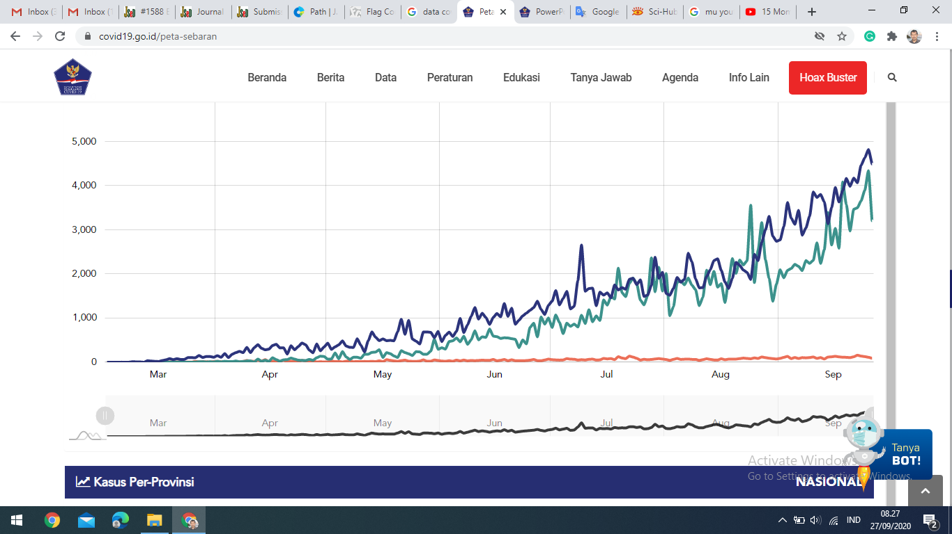

<https://covid19.go.id/peta-sebaran>

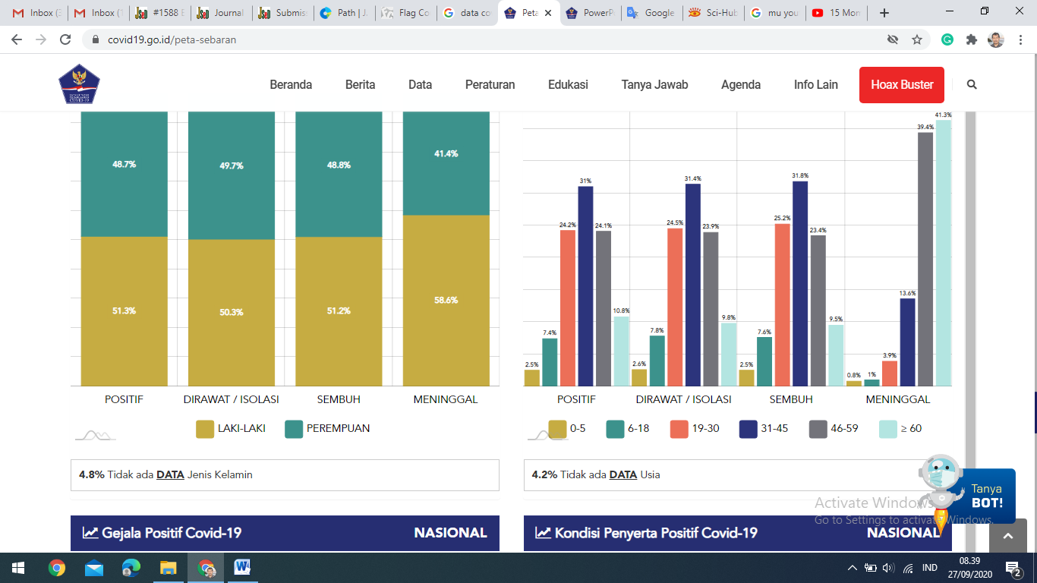

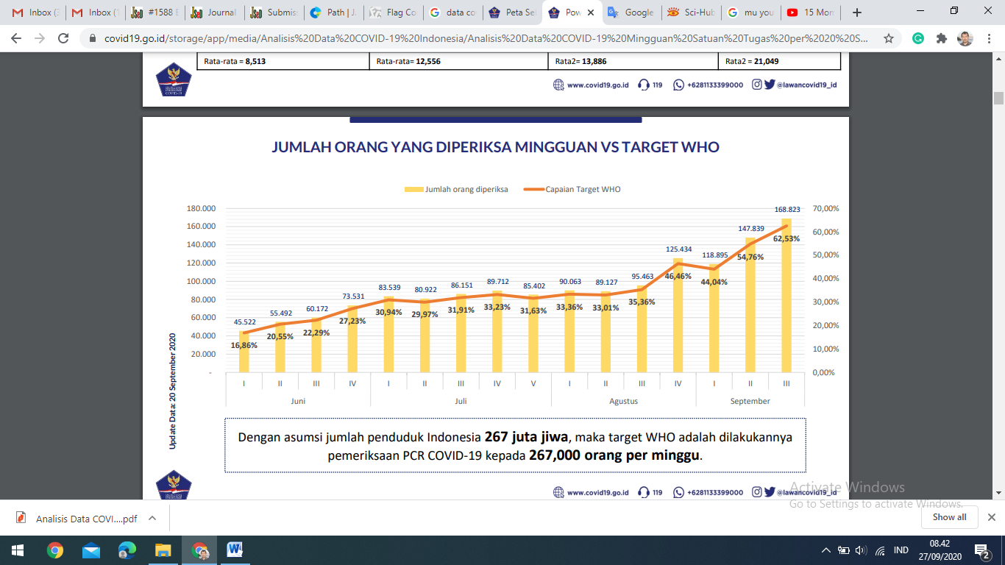

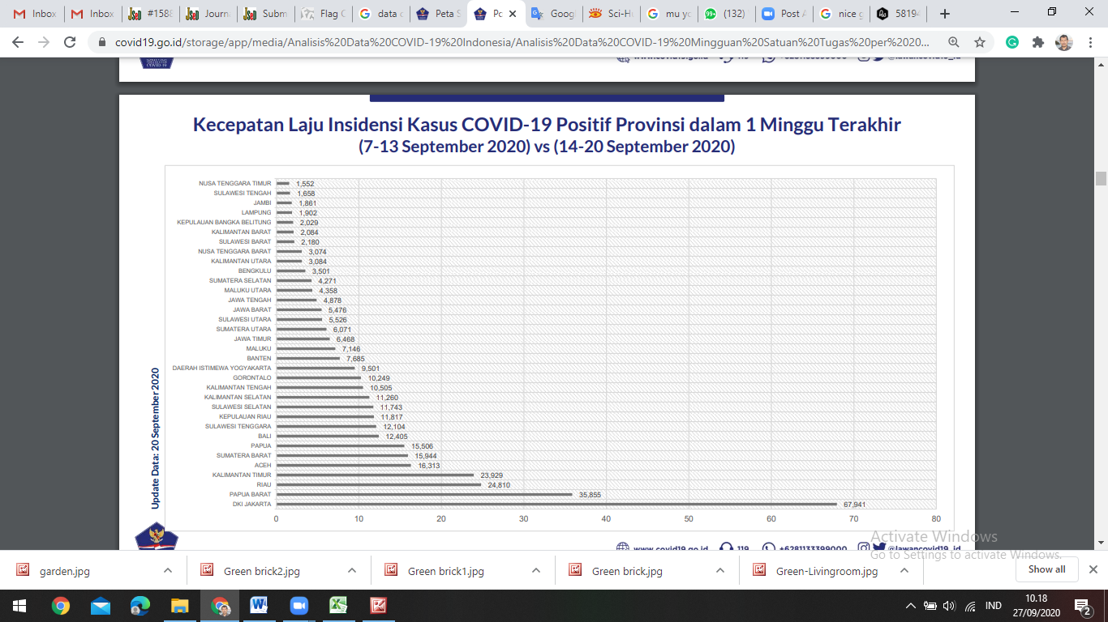

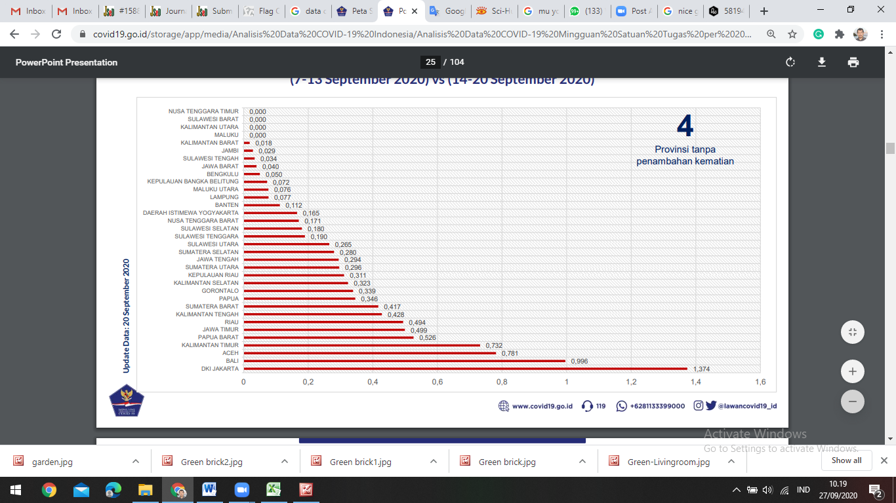

I did not truly start considering the long-term impact this virus would have until the secondand third weeks of quarantine. While roughly 500 patients had tested positive in Texas by the end ofMarch, positive cases in New Jersey numbered nearly 3,000. Over the past two months, BergenCounty, a county in Northern New Jersey of roughly 1 million residents, including my parents, hasbeen impacted to the greatest extent, with over 11,000 confirmed cases and 650 deaths as of April17th. As I was still in Texas, my parents updated me daily on new mandates, such as nightly curfews,store closures, wearing masks in public, and limiting the number of shoppers in grocery stores. Wespoke about medically vulnerable relatives at risk of exposure and people who had lost their entirelifesavings, as businesses were forced to permanently close due to financial hardships. My friends inmedical school also called to tell me about the shelf exams, clinical rotations, and graduations that had been cancelled across the country . **Christine E. Wamsley** (Wamsley, 2020)

This volume 20 of the Journal of Urban Culture Research was created in the midst of the of the Covid-19 pandemic. Here in Thailand restrictions began in March and remain in place today. This crisis has caused many changes creating a “New Normal” life of social distancing among other changes in society.

Regarding the limitation of social contact, social media has been instrumental in bringing forth performances, including Thai music, folk, pop and classical. People get together to perform music using the Zoom conferencing program to put together an online ensemble. There are numbers of music video clips emerging to support a new way of life in line with government policies to avoid being victim of asymptomatic or super spreaders. Drawings and paintings are being displayed through virtual galleries. Graphic designs and animations also play significant roles in accompanying songs and performances. Visual arts and digital arts are coming forth being used for promoting health and related safety campaigns. Though urban art and culture have been impacted by Covid-19 throughout the world, it is a good opportunity to initiate a “New Normal” way of practice for all artists and urban research scholars in this new era. **Bussakorn Binson** (Binson, 2020)

The COVID-19 pandemic not only caused a health crisis, but also a global economic crisis. The widespread impact led the economy to changes to new normal conditions. This raises many important research topics in various fields such as health economics, public economics and public finance, institutional economics, international trade, environmental economics, development economics, behavioral economics, and many others to provide references for decision-makers. Such studies not only help to accelerate the recovery of the tourism industry from short-term shocks caused by the pandemic and economic crisis, but also the recovery of the national econom **Tri Haryanto** (Haryanto, 2020)

The importance of those providing this care remains central as this disease remains active, kinetic, and threatening. It will become equally if not more important as this storm diminishes. Many people are likely to suffer from PTSD. Just as many, if not more, may become overwhelmed with moral distress. Both share many common characteristics, but the latter can be more hidden and problematic. Moral distress emerges when individuals sense of meaning and worth become uncertain. Moral distress is an existential threat that, if not addressed, may challenge full recovery from trauma. The moral distress generated by COVID-19 is likely to be experienced by everyone, care providers and non-caregivers alike. Feelings such as guilt, failure, and lack of worth at an existential level characterize moral distress. Attempts to help manage, work through, and let go of these feelings often fail because, with moral distress, people are often unable to reclaim their own egostrength. They often feel unempowered and worthless. In such a state, what many people want and need is someone to afﬁrm their value. They seek someone to whom they may regard as more authoritative. Their positive transference often on such “authorities” cries out for validation and worth by simply taking on the role of forgiver. (Bard, 2020)

Dalam Peraturan Menteri Kesehatan (Permenkes) Nomor 9 Tahun 2020, disebutkan bahwa PSBB adalah pembatasan kegiatan tertentu penduduk dalam suatu wilayah yang terduga terinfeksi Corona Virus Disease 2019 (COVID-19) sedemikian rupa untuk mencegah Corona Virus Disease 2019 (COVID-19). 2 Penetapan PSBB yang dilakukan oleh pemerintah Indonesia memiliki dasar pertimbangan seperti epidemiologis, besarnya ancaman, efektivitas, dukungan sumber daya, teknis operasional, pertimbangan ekonomi, sosial, budaya dan keamanan. PSBB yang telah dikeluarkan oleh pemerintah memiliki lingkup yaitu: 1. Peliburan sekolah dan tempat kerja 2. Pembatasan kegiatan keagamaan, sosial budaya di tempat umum atau fasilitas umum 3. Moda transportasi 4. Kegiatan lainnya khusus terkait aspek pertahanan dan keamanan Namun pemerintah tetap membiarkan layanan-layanan tertentu untuk tetap berjalan seperti biasa di antaranya adalah supermarket, pasar/toko penjualan obat-obatan dan peralatan medis, kebutuhan pangan, bahan pokok, barang penting, bahan bakar minyak, gas dan energi, pelayanan kesehatan dan kegiatan olahraga, transportasi umum dan berpedoman pada pembatasan kerumunan dan protokol yang berlaku. Penerapan PSBB yang dilakukan oleh pemerintah Indonesia dilihat sebagai upaya untuk membatasi pergerakan serta atau masyarakat untuk mengurangi risiko dari penyebaran virus corona yang semakin meluas. Dengan diterbitkannya kebijakan PSBB oleh pemerintah Indonesia maka suatu daerah atau wilayah yang telah ditetapkan PSBB harus mengurangi segala kegiatan yang dilakukan di luar rumah. Dengan adanya cara ini diharapkan dapat menurunkan jumlah pasien positif corona di Indonesia

Ada dugaan bahwa keinginan melonggarkan PSBB ini sebetulnya mengikuti tren negara lain yang bisa dikatakan berhasil meredam corona, seperti Taiwan, Jepang, dan Swedia. Tiga negara tersebut sudah berhasil meminimalisasi transmisi lokal di wilayah mereka. Sedangkan, hal tersebut belum bisa dibuktikan berhasil di Indonesia

Kondisi di Indonesia diperparah dengan tidak disiplinnya masyarakat. Kerumunan masih banyak dijumpai di banyak tempat, termasuk pusat perbelanjaan terutama jelang hari raya beberapa hari terakhir (Vitalio, Turnip, & Louis IX King, 2020)

This study showed that the majority of the respondents had a good attitude, meaning they were aware of the importance of social distancing. This is the first study in Indonesia to identify knowledge, attitude and behavior towards social distancing. This study explained that a positive attitude results in good behavior. Attitude is an action of positive or negative tendency related to psychological objects. Real attitude shows the connotations of the suitability of reactions to certain stimuli, which in everyday life are emotional reactions. According to Thurston (1928), attitude as an action of a positive or negative tendency is associated with psychological objects. Actual attitudes show the connotation of the suitability of reactions to certain stimuli which in everyday life are emotional reactions to social stimuli. Attitude is the readiness to react to objects in a particular environment as a recognition of the objects. Therefore, conducting social distancing requires the community’s readiness.

Attitude is one of the variables that influence intention. Attitude towards behavior is one of the strong determinants of a weak intention to behave. A positive attitude towards behavior will increase the intention to behave and recognition of the behavior. Conversely, a negative attitude toward behavior will reduce the intention to behave and recognition of the behavior (Huda et al., 2012). This finding is consistent with the results of this study which showed that the Indonesian community had a positive attitude along with good behavior. Indeed, the influence of attitude on behavior is reinforced through intention. In addition to perceived behavior control, a positive attitude influences strong intention to perform social distancing in the community. (Yanti et al., 2020)

Face masks have become an emblem of the public response to COVID-19, with many governments mandating their use in public spaces. The logic is that face masks are low cost and might help prevent some transmission. However, from the start, the assumption that face masks are “low cost” was questioned. Early on, there were warnings of the opportunity cost of public use of medical masks given shortages of personal protective equipment for healthcare providers. This led to recommendations for cloth masks and other face coverings, with little evidence of their ability to prevent transmission. However, there may also be a high cost to these recommendations if people rely on face masks in place of other more effective ways to break transmission, such as staying home. We use SafeGraph smart device location data to show that the representative American in states that have face mask mandates spent 20-30 minutes less time at home, and increase visits to a number of commercial locations, following the mandate. Since the reproductive rate of SAR-COV2, the pathogen that causes COVID-19 is hovering right around one, such substitution behavior could be the difference between controlling the epidemic and a resurgence of cases.

Evidence suggests that staying home effectively reduced transmission. One concern with that conclusion is that it is easier to observe staying home behavior than hand-washing and face mask-wearing. Yet, the evidence of the effectiveness of face mask use by the general public on disease transmission is less conclusive. Furthermore, for face masks to be effective, they must be used correctly. This includes having a tight seal, which requires things like a clean shave, having one’s nose in the mask, and leaving the mask on while talking to someone. One need only look at images of mask-wearing in public to conclude that a non-trivial share of the mask wearers are not wearing them correctly or that the masks themselves are of questionable quality (i.e., bandannas). It is certainly possible that misused masks do not increase transmission, and may reduce it, holding other behaviors constant. The challenge is that the introduction of the wide use of face masks appears to alter those other behaviors. Our results suggest that wearing a mask needs to be as effective as all individuals in society reducing their time out of the house by approximately 4 percent or 20-30 minutes. Bayham et al. (2015) found that voluntary behavioral change of a similar magnitude reduced swine flu cases on the order of 10 percent. This is likely a lower bound for the value of an additional 20-30 minutes at home for reducing COVID-19 cases. Are face masks that effective? Our results provide a benchmark for future testing of the effectiveness of face masks in the general public. Messaging around behavioral interventions needs to be done carefully. Masks have been introduced. Our results should not be used as a justification for discouraging face mask use. Rather, extreme care must be taken when suggesting new behaviors that may be helpful in order to avoid replacing behaviors that are known to be helpful. The message to wear a face mask in public is at least suggestive that it is safer to resume public interactions with a mask. However, time in public is still riskier than time at home and can still enable transmission from asymptomatic individuals. Concerns about behavioral substitution are sometimes treated as curiosities. Requiring seat belts likely outweighs the damage from riskier driving and energy efficiency reduces carbon emissions even if it leads to more device use (Gillingham et al. 2013). Even encouraging condom use has likely prevented more cases of HIV, then the risk compensation generated. However, in the case of the highly contagious pathogens SAR-COV-2, which causes COVID-19, a small amount of risk compensation behavior could lead to an exponential increase in cases. The difference between a few trips with a mask and staying home, spread across the entire population could be the difference between the reproductive rate of the pathogen (R(t)) exceeding one, and renewed exponential growth, and a reproductive rate less than one and containing the epidemic. If people must go out, then it is probably advisable to wear a mask. However, the fact that people now own masks is likely making them more likely to even consider a trip to a warehouse club, a home improvement store, or a liquor store. Ultimately, these marginal trips could make the epidemic more difficult to bring under control. (Yan, Bayham, Fenichel, & Richter, 2020)

Although digital communications, in particular social media, generate social capital,8 2 important caveats must be considered. First, previous research investigating social media and social capital took place under normal circumstances, when individuals had access to both online and offline forms of communication. Although social media has been linked to social capital in that context, existing research does not address that connection in the current context of reduced face-to-face communication. Second, online and offline social capital, while related, are distinct phenomena.9 Whereas offline social capital has been the subject of decades of inquiry, online social capital is a relatively new phenomenon and has not (to date) received the same level of scholarly attention.

The deficiencies in social capital documented by Putnam, and exacerbated by physical distancing, also have direct implications for adherence to specific protective behaviors that are critical to flattening the COVID-19 epidemic curve. During the H1N1 pandemic, social capital (measured through trust in government and interpersonal contacts and feelings of mutual obligation, reciprocity, and social cohesion) emerged as a predictor of behaviors such as intention to vaccinate, handwashing, and wearing a face mask.2,3 Because protective measures during the COVID-19 pandemic rely on adherence by symptomatic and asymptomatic individuals alike, the same features of social capital are integral to adherence. Unfortunately, trust in government, which was already at historic lows,11 has been further undermined during the pandemic.12 This lack of trust in government— the result of misinformation and missteps at the federal level13— reduces adherence to protective measures and ultimately weakens the public health response to the pandemi

1. Individuals, communities, and government institutions should focus on building and maintaining a variety of social ties during the present crisis. Social capital, of all forms, will increase adherence to, and improve the efficacy of, physical distancing and other protective behaviors.2,3 Recognizing the extended length of this disaster, with no discrete end in sight, sustainability of response and recovery efforts is also a paramount concern, which if past disasters are any indication, will hinge to some degree on social capital.1,2,4 Social connections—with immediate household members, fellow members of the local community, and Americans from diverse and disparate backgrounds—will be critical in our collective response to COVID-19.

2. Digital mediated communication tools must play a larger role in generating social capital during the current pandemic.8 Although the effects of social media– based social capital are less well understood,9 digital and other mediated forms of communication must be utilized as a means of creating and nurturing socialconnections. Platforms such as Facebook, Twitter, and Instagram are already using their reach to spread curated, factual information about the pandemic and actively removing potentially harmful misinformation. Schools and workplaces are also turning to remote connections in an unprecedented fashion. With limited access to social environments such as schools, workplaces, parks, and other public spaces, we must effectively leverage the digital commons as never before. This dependence on digital communication also provides a powerful context for further examination of the effects of social mediabased social capital, specifically in this unique context where face-to-face interactions are necessarily limited.

3. Finally, we must learn from the effects of the current crisis and prepare for future disaster scenarios. The impacts of COVID-19 on social capital, and the role of social capital in responding to COVID-19, must be the subject of rigorous, ongoing research. Just as previous epidemic and pandemic scenarios have provided critical information in use today,2,3 lessons learned from COVID-19 must be incorporated into the disaster response cycle. It is not a question of if future pandemics will arise, but rather when. A more thorough understanding of effective strategies for building and maintaining social capital during periods of social isolation using digital communication tools, will be a valuable tool in future crises. As confirmed by the current crisis, and countless others before, the time to prepare is before the water begins to rise, rather than when the levee breaks (Pitas & Ehmer, 2020)

The physical isolation component of the concept is more than likely a negative factor, bringing noises to positive coping, increasing negative coping, and lowering subjective wellbeing. However, intimate relations and informational diversity, the two social components of the concept, produce highly consistent and positive results, increasing all measured behavioral responses and quality life indicators. The most impressive findings are the significant and very large effects of intimate relations on all seven dependent variables. These make it explicit that core personal networks centered around and extended from the family are the single best source of social capital helping Chinese people combat the pandemic of COVID-19. The construction of virus-combat social capital has benefited from the literature on tie-strength and social resources as measures of social capital, paying attention to the bonding functions of intimate circles of strong ties and the bridging functions of distant contacts of weak ties. Limited by an eight-minute online survey of WeChat networkers, we did not intend to include measures of network structure, which would require extensive time investments from respondents to answer questions about connections among named social contacts. Nevertheless, our survey findings imply the importance and complementarity of network closure and network brokerage because intimate relations and distant contacts jointly facilitate and strengthen an individual’s behavioral responses to COVID-19 and jointly generate effective mental and physical anti-epidemic outcomes. Since the COVID-19 pandemic is anticipated to last long before the invention of vaccines, and because new viruses may unfortunately affect human life in the future, the concept of virus-combat social capital is of continuous significance to scholarship on social mechanisms to fight against the viral spreading. It is in this regard that the China case study reported here has established a benchmark for future cross-national analysis.(Bian, Miao, Lu, Ma, & Guo, 2020)

The Coronavirus disease (COVID-19) is the first pandemic in history in which technology and social media are being used on a massive scale to keep people safe, informed, productive and connected. At the same time, the technology we rely on to keep connected and informed is enabling and amplifying an infodemic that continues to undermine the global response and jeopardizes measures to control the pandemic.

An infodemic is an overabundance of information, both online and offline. It includes deliberate attempts to disseminate wrong information to undermine the public health response and advance alternative agendas of groups or individuals. Mis- and disinformation can be harmful to people’s physical and mental health; increase stigmatization; threaten precious health gains; and lead to poor observance of public health measures, thus reducing their effectiveness and endangering countries’ ability to stop the pandemic.

Misinformation costs lives. Without the appropriate trust and correct information, diagnostic tests go unused, immunization campaigns (or campaigns to promote effective vaccines) will not meet their targets, and the virus will continue to thrive.

Furthermore, disinformation is polarizing public debate on topics related to COVID-19; amplifying hate speech; heightening the risk of conflict, violence and human rights violations; and threatening long-terms prospects for advancing democracy, human rights and social cohesion.

In this context, the UN Secretary- General launched the United Nations Communications Response initiative to combat the spread of mis- and disinformation in April 2020. The UN also issued a Guidance Note on Addressing and Countering COVID-19 related Hate Speech (11 May 2020).

At the World Health Assembly in May 2020, WHO Member States passed Resolution WHA73.1 on the COVID-19 response. The Resolution recognizes that managing the infodemic is a critical part of controlling the COVID-19 pandemic: it calls on Member States to provide reliable COVID-19 content, take measures to counter mis- and disinformation and leverage digital technologies across the response. The Resolution also calls on international organizations to address mis- and disinformation in the digital sphere, work to prevent harmful cyber activities undermining the health response and support the provision of science-based data to the public.

https://www.who.int/news-room/detail/23-09-2020-managing-the-covid-19-infodemic-promoting-healthy-behaviours-and-mitigating-the-harm-from-misinformation-and-disinformation

The fact that a COVID-19 R&D forum was the first meeting convened after the PHEIC declaration testifies to the importance of R&D in response to EID. Korea has demonstrated a remarkable capacity in its laboratory response by conducting high-throughput COVID-19 testing and utilizing innovative drive-through samplings. These measures for early detection and screening of cases should be followed by full efforts to produce research-based evidence by thoroughly analyzing epidemiological, clinical and immunological data, which will facilitate the development of vaccines and therapeutics for COVID-19. It is expected that Korea plays a global partner for COVID-19 research by actively participating in immediate and mid/long-term priorities jointly led by WHO and global partners (Jee, 2020)

In this issue of the Journal of Medical Internet Research, the World Health Organization (WHO) is presenting a framework for managing the coronavirus disease (COVID-19) infodemic. Infodemiology is now acknowledged by public health organizations and the WHO as an important emerging scientific field and critical area of practice during a pandemic. From the perspective of being the first “infodemiologist” who originally coined the term almost two decades ago, I am positing four pillars of infodemic management: (1) information monitoring (infoveillance); (2) building eHealth Literacy and science literacy capacity; (3) encouraging knowledge refinement and quality improvement processes such as fact checking and peer-review; and (4) accurate and timely knowledge translation, minimizing distorting factors such as political or commercial influences. In the current COVID-19 pandemic, the United Nations has advocated that facts and science should be promoted and that these constitute the antidote to the current infodemic. This is in stark contrast to the realities of infodemic mismanagement and misguided upstream filtering, where social media platforms such as Twitter have advertising policies that sideline science organizations and science publishers, treating peer-reviewed science as “inappropriate content (Eysenbach, 2020)

Secara umum, infeksi penyakit pernapasan menyebar melalui penularan tetesan dan aerosol yang mengandung virus yang dihembuskan dari individu yang terinfeksi selama bernafas, berbicara, batuk, dan bersin. Khusus penyebaran penyakit COVID-19 tampaknya terjadi melalui transmisi aerosol oleh individu yang sakit atau bahkan tanpa gejala selama bernafas dan berbicara. Aerosol tersebut dapat berakumulasi di udara dalam ruangan selama berjam-jam, berpotensi dihirup ke dalam paru-paru oleh individu lain (Prather, Wang, & Schooley, 2020).

Upaya penanganan pengurangan penularan aerosol yang mengandung virus umumnya dengan berbagai penapisan yang bersifat individual atau berskala sosial. Pengendalian transmisi aerosol individual misalnya penggunaan masker, alat pelindung diri, atau upaya kebersihan dan kesehatan. Pengendalian transmisi bersifat sosial dipilih dengan gerakan sosial melalui upaya menjaga jarak, penutupan sekolah atau aktivitas layanan publik dan penutupan wilayah (Kissler, Tedijanto, Lipsitch, & Grad, 2020; Kleczkowski, Maharaj, Rasmussen, Williams, & Cairns, 2015).

Upaya melakukan pembatasan sosial perlu dilakukan sedini mungkin agar penyebaran virus segera berhenti (Kraemer et al., 2020). Namun demikian, ada diskusi yang panjang terkait implikasi pembatasan sosial. Aktivitas ekonomi juga penting untuk memberi jaminan kehidupan masyarakat, dan masih dibutuhkan untuk menyelesaikan problem pembangunan secara umum. Di negara sedang berkembang, implikasi pembatasan sosial menunjukkan sangat komplek. (von Braun, Zamagni, & Sorondo, 2020) menyatakan pembatasan sosial hanya layak untuk orang kaya. Orang kaya mampu tinggal di rumah, memiliki masker dan alat pelindung diri, bahkan bisa mengakses teknologi untuk bekerja atau belajar dari rumah. Orang miskin tidak memiliki pilihan banyak, mereka harus bekerja, melakukan perjalanan, menghadapi resiko kesehatan, dan anaknya tidak mampu mengakses pendidikan online.

Karena itu, pembatasan sosial tidak dapat berlangsung lama. Begitu kurva jumlah kasus infeksi mulai melandai atau menurun, pembatasan sosial dapat dikurangi (Kissler et al., 2020). Dampak pandemi COVID-19 perlu disikapi secara positif dengan mengembangkan potensi-potensi sosial dengan tetap mematuhi protokol kesehatan. (Hodges & Jackson, 2020) menyatakan bahwa saatnya memikirkan kembali institusi budaya, yang mampu memberikan ketahanan bagi keberlangsungan kehidupan, serta menumbuhkan kembali ekonomi. Dalam kehidupan yang disebut new normal itu, setiap orang perlu membangun budaya baru dengan mengimplementasikan pandangan, gaya hidup, dan perilaku ekonomi baru. Masyarakat perlu menunjukkan tanggung jawab sosial, lebih banyak berbagi, lebih peduli, lebih inklusif, dan mematuhi protokol kesehatan (von Braun et al., 2020; Walker et al., 2020).

Pada saat ini (update 21 Juni 2020), data penduduk Indonesia yang positif terinfeksi sejumlah 45029 orang, 17883 sembuh, dan 2429 meningggal dunia (https://covid19.go.id/). Kecenderungan peningkatan kasus diduga masih akan terjadi. Upaya melakukan pembatasan sosial telah dilakukan di berbagai wilayah yang menunjukkan jumlah kasus signifikan. Namun, pemerintah Indonesia, dan juga negara lain, juga mempersiapkan untuk melakukan pemulihan ekonomi melalui konsep new normal. Konsep new normal adalah membuka kembali aktivitas layanan publik dan ekonomi bisnis dengan secara ketat menjalankan protokol kesehatan, misalnya menjaga jarak, menggunakan masker, cuci tangan, dan memelihara kesehatan; didukung standar prosedur penanganan layanan kesehatan.

Namun demikian, memasuki kondisi new normal menyisakan pertanyaan yang besar. Pada satu sisi, kurva jumlah kasus infeksi masih menunjukkan kenaikan, dan pada saat sama, protokol kesehatan belum dijalankan secara disiplin oleh masayarakat. Sebagaimana dikemukakan (von Braun et al., 2020), banyak masyarakat belum mematuhi rambu-rambu pembatasan sosial dan protokol kesehatan karena harus memenuhi kehidupan ekonomi. Pandemi COVID-19 di Indonesia memunculkan istilah baru terkait dengan social distancing, work from home, atau self-isolation, atau lockdown. Masyarakat, kehidupan bisnis atau pemerintah terlambat merespon hal tersebut. Pada saat yang sama sebaran informasi begitu kuat, masyarakat tidak mampu menapis informasi dari hoax (Djalante et al., 2020). Hal ini menjadi pertanyaan besar dalam menghadapi periode new normal.

Sementara itu, di masyarakat juga muncul reaksi positif menyikapi pandemi COVID-19. Sebagaimana (Hodges & Jackson, 2020), peran institusi atau budaya dapat bereaksi secara positif dan mampu memberikan ketahanan dalam pandemi. Ketahanan masyarakat dapat didekati melalui konsep kapasitas sosial dan modal sosial. Ini terlihat dari respon masyarakat dalam masa pandemi dengan membantu masyarakat terdampak, misalnya membagi bahan pokok, membagi masker, pembatasan tamu, mengaktifkan pos keamanan swadaya, dan aktivitas solidaritas sosial lainnya (Djalante et al., 2020). Pada saat yang sama aktivitas ekonomi memunculkan fenomena baru, yakni munculnya transaksi online atau direct selling dari produsen ke konsumen tanpa melalui pasar akibat penerapan pembatasan wilayah.

Kapasitas sosial adalah intrumen yang mampu mengorganisasikan kompleksitas, melalui pengaturan, kerjasama dan pemberdayaan pihak-pihak yang terlibat. Bangunan kapasitas sosial menjadi komponen penting dalam keberlanjutan pengelolaan sumberdaya (Schwaninger, 2018). Modal sosial adalah konsep yang mengacu kepada ikatan-ikatan sosial (Putnam, 2001) untuk menghasilkan pemberdayaan dan partisipasi masyarakat disertai komitmen dan kinerja kehidupan yang optimal (DeFilippis, 2001; Fukuyama, 2000). Modal sosial adalah fondasi masyarakat yang dapat menyelesaikan masalah dan merupakan kekuatan bagi masyarakat untuk mandiri dan mempertahankan diri. Semakin banyak modal sosial yang dimiliki, semakin kuat pula kapasitas sosial masyarakat tersebut (Amornsiriphong, Piemyat, & Charoenrat, 2012). Modal sosial sebagai stok, menyediakan medium bagi berkembangnya kapasitas sosial. Kapasitas sosial memberikan arahan perencanaan manajemen suatu sumberdaya berkelanjutan.

Memasuki kehidupan new normal tentu sangat menarik untuk diteliti. Dua masalah yang ingin diaddress adalah bagaimana kedisiplinan menjalankan protokol kesehatan dan pembatasan sosial, dan bagaimana kepasitas sosial dan modal sosial sebagai ukuran ketahanan masyarakat menghadapi pandemi COVID-19. Dalam penelitian ini, modal sosial didekati dari deskripsi norma, trust, jaringan dan partisipasi. Sementara kapasitas sosial didekati dari pengaturan hubungan aspek sosial, social distancing dan ekonomi dalam pengelolaan penanganan COVID-19. Pengaturan dapat membentuk model pengelolaan, menunjukkan komponen paling kritikal, dan menyediakan alternatif pengambilan keputusan dalam pengelolaan penanganan COVID-19. Tema penelitian ini belum pernah diteliti sebelumnya.

Penelitian ini bertujuan untuk mendeskripsikan peran modal sosial dan implementasinya dalam kapasitas sosial dalam masa pandemi COVID-19 dan menuju new normal.

**TINJAUAN PUSTAKA**

**Social Distancing dan Pandemi COVID-19**

Upaya penanganan penyebaran penyakit infeksi pernafasan umumnya melalui social distancing, disertai upaya intervensi lain seperti penutupan sekolah atau aktivitas layanan publik dan penutupan wilayah (Kissler et al., 2020; Kleczkowski et al., 2015). Social distancing adalah aspek perilaku manusia yang sifatnya universal. Setiap orang dapat mengurangi tingkat kontak dengan orang lain dengan mengubah perilaku mereka, untuk mengurangi penularan banyak penyakit. Menurut (Reluga, 2010), social distancing sangat berguna dan beroperasi murah, dan dapat menunda epidemi untuk penyakit menular sedang sampai ditemukannya vaksin untuk mematikan virus. Namun, manfaat dari social distancing relatif kecil untuk penyakit yang sangat menular ketika tidak ada vaksin. (Kleczkowski et al., 2015) menyatakan social distancing juga penting ketika sistem dan fasilitas kesehatan belum memadai, atau untuk mencegah beban tenaga kesehatan.

(Bauch & Galvani, 2013) telah mengidentifikasi SARS-coronavirus sebagai virus yang berbahaya, dan belum ditemukan obat atau vaksinnya. Oleh karena itu, penanganan kesehatan masyarakat harus bergantung pada karantina, pembatasan pergerakan, dan tindakan lain yang memerlukan perilaku kooperatif. Kekurangan pengetahuan epidemiologis seperti COVID-19 saat sekarang ini, dapat menimbulkan rasa takut, dan berpotensi menerima informasi yang tidak benar. Peningkatan pemahaman tentang interaksi antara penularan sosial dan penularan biologis akan membantu meningkatkan upaya pengendalian penyakit.

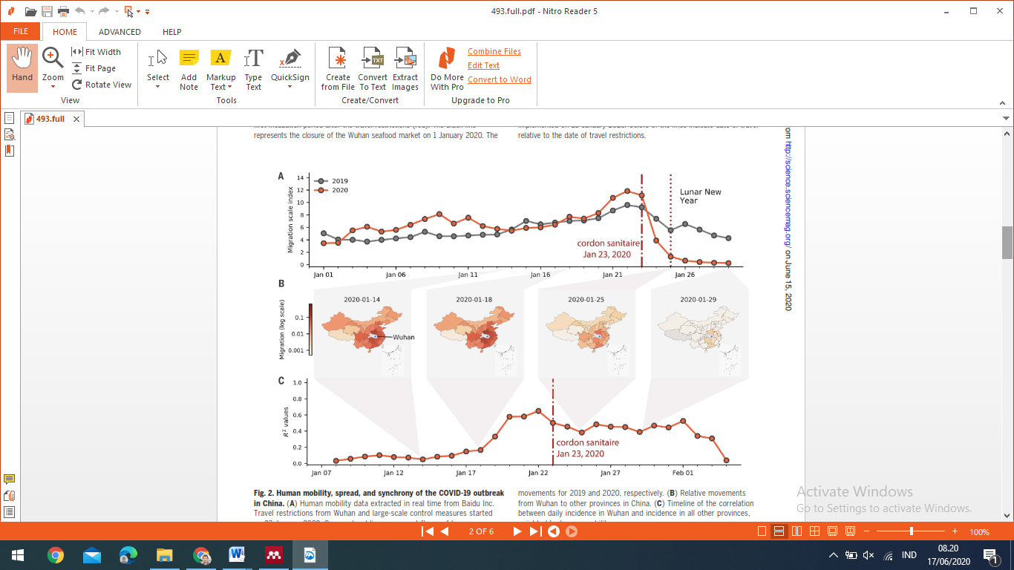

Gambar 1. Perkembangan mobilisasi manusia di kota Wuhan, sebelum dan setelah diberlakukan lockdown pada tanggal 23 Januari 2020 (Kraemer et al., 2020)

Implementasi social distancing di pusat epidemi COVID-19 di Wuhan, Cina, memberikan contoh kasus yang berhasil (Gambar 1). Menurut (Kraemer et al., 2020), social distancing sangat berguna pada tahap awal wabah pada area yang sudah diidentifikasi sebagai sumber utama epidemi. Hal ini berhasil dalam mengurangi penyebaran dan mengurangi transmisi COVID-19 lokal. Namun, social distancing mungkin kurang efektif setelah wabah meluas. Hal ini memerlukan kombinasi intervensi yang lebih rumit dan memberikan hasil yang tidak pasti. Social distancing perlu menyeimbangkan secara optimal efek positif kesehatan masyarakat dengan dampak negatif pada kebebasan bergerak, ekonomi, dan masyarakat pada umumnya.

Pada saat ini, hampir semua negara sudah menunjukkan pemulihan kehidupan dalam berbagai bidang. Namun, semua pihak menyadari bahwa pandemi COVID-19 belum sepenuhnya berakhir. Indonesia, juga melakukan pemulihan ekonomi melalui konsep new normal. Konsep new normal adalah membuka kembali aktivitas layanan publik dan ekonomi bisnis dengan secara ketat menjalankan protokol kesehatan, misalnya menjaga jarak, menggunakan masker, cuci tangan, tidak menyentuh muka atau mata, mengupdate info yang benar dan memelihara kesehatan; didukung standar prosedur penanganan layanan kesehatan ([covid19.go.id](https://covid19.go.id/edukasi/apa-yang-harus-kamu-ketahui-tentang-covid-19/adaptasi-kebiasaan-baru)).

Pandemi COVID-19 memberikan banyak pelajaran berharga. Pendekatan multidisiplin diperlukan untuk mengatasi berbagai faktor yang mengarah pada penularan virus pernapasan melalui udara (Prather et al., 2020). Menurut (Hodges & Jackson, 2020), masyarakat memikirkan kembali institusi budaya, yang mampu memberikan ketahanan bagi keberlangsungan kehidupan, serta menumbuhkan kembali ekonomi. Dalam kehidupan yang disebut new normal itu, setiap orang perlu membangun budaya baru dengan mengimplementasikan pandangan, gaya hidup, dan perilaku ekonomi baru. Dunia tidak dapat kembali ke bisnis seperti biasa. Diperlukan masyarakat yang lebih bertanggung jawab, lebih banyak berbagi, lebih peduli, lebih inklusif, dan lebih adil agar kehidupan tetap bertahan (von Braun et al., 2020).

Semua pihak telah menunjukkan kerjasama dalam penanganan pandemi COVID-19. Masyarakat berinisitif menggunakan kemampuannya membantu upaya pemerintah melaksanakan program social distancing atau kegiatan lainnya. Di Korea, kelompok wanita menjadi relawan untuk menemukan, melaporkan, dan memonitor orang terduga atau pasien COVID-19, melakukan penyemprotan disinfektan, dan membantu membuat masker. Di Cina, penduduk melakukan pengawasan dan melarang kedatangan tamu. Negara seperti Singapura, Korea Selatan, dan Cina secara agresif telah membangun jaringan pemantauan pencegahan pandemi melalui penggunaan teknologi big data, artiﬁcial intelligence, open-science dan citizen-data (Shaw, Kim, & Hua, 2020)

Di Indonesia, respon pemerintah dan masyarakat terhadap pandemi dianggap terlambat. Pada saat itu juga menyebar informasi liar dan hoax yang dipahami tidak benar tentang pandemi, sehingga menimbulkan kepanikan. Memahami istilah work from home, lockdown, social distancing, isolasi mandiri, menggunakan masker, cuci tangan bukan hal yang mudah. Namun, hal ini segera dipahami ketika semakin banyak kasus infeksi muncul dan mulai jatuh korban meninggal. Masyarakat akhir menunjukkan tanggapan seperti bantuan sosial bagi keluarga yang terinfeksi, mengisolasi keluarga yang baru datang, atau pembatasan kedatangan tamu (Djalante et al., 2020).

**Kapasitas Sosial dan Modal Sosial**

Kapasitas sosial adalah konsekuensi dari modal sosial. Kapasitas sosial menggambarkan aliran / konsekuensi dari modal sosial selama periode tertentu. Kapasitas sosial juga dapat didefinisikan sebagai pertumbuhan atau perkembangan setiap tingkat hierarki manusia atau integrasi sosial dalam rentang spasial tertentu. Hence, social capacity consists of the sum of human capacity and the additional aspects to be achieved through cooperation, integration or interaction (Mauerhofer, 2013).

Kapasitas sosial adalah intrumen yang mampu mengorganisasikan kompleksitas, melalui pengaturan, kerjasama dan pemberdayaan pihak-pihak yang terlibat. Meningkatnya kapasitas lokal ditandai oleh membaiknya situasi antara lain kesadaran dan pengetahuan ekowisata, pemberdayaan dan partisipasi, kepemimpinan lokal, dan organisasi (Rasid, Mustafa, Suradin, & Hassan, 2012), serta kewirausahaan dan inovasi (Purnomowati, Nugroho, & Negara, 2012). Manajemen dan kemimpinan organisasi berfungsi mengarahkan pengembangan sumberdaya dan kontribusi manfaat yang berkelanjutan. Kapasitas sosial mengalir dari modal sosial yang merupakan stok atau sumber. Konsepsi modal sosial sebagai stok menyediakan medium mekanisme alokasi sumberdaya, meliputi aspek sosial, lingkungan dan ekonomi (Mauerhofer, 2008). Kapasitas sosial dapat tumbuh berkembang sejalan dengan pertumbuhan stok social capital.

Modal sosial adalah konsep yang mengacu kepada ikatan-ikatan sosial (Putnam, 2001) untuk menghasilkan pemberdayaan dan partisipasi masyarakat disertai komitmen dan kinerja kehidupan yang optimal (DeFilippis, 2001; Fukuyama, 2000). Ikatan itu adalah hasil interaksi dari norma, tradisi, agama, pengalaman sejarah (Fukuyama, 2001), dan di dalamnya memuat berfungsinya power, wewenang, dan trust (kepercayaan) (Newton, 2001; Nunkoo, Ramkissoon, & Gursoy, 2012).

Modal sosial membentuk suatu kelembagaan yang dilandasi norma tertentu, yang mengikat berbagai kepentingan (jaringan), sekaligus membentuk trust dan motivasi untuk mengkontribusi manfaat dari pengelolaan suatu sumberdaya (Sunkar, Meilani, Rahayuningsih, & Muntasib, 2016). Pengelolaan sumberdaya berjalan optimal karena berfungsinya faktor-faktor norma, trust, collectivism, authority dan kohesivitas sosial (Grootaert, Narayan, Jones, & Woolcock, 2004; Yolles, 2018).

Implementasi modal sosial dalam dalam pengembangan wisata telah banyak dipelajari. (Nunkoo et al., 2012) mempelajari peran institusi, kewenangan dan trust antar penduduk lokal menjadi penentu dalam mengembangan usaha jasa wisata. (Bennett & Dearden, 2014) memandang penting saling percaya (trust) antara penduduk lokal dan taman nasional dalam rangka pengelolaan sumberdaya pesisir yang berkelanjutan. Persepsi negatif lahir karena tidak ada trust, tentang peran para pihak dan apa yang dapat dikontribusikan. Trust dapat melahirkan hubungan antar personal yang positif dan melahirkan collective action untuk mengembangkan wisata (Sunkar et al., 2016).

(Baksh, Soemarno, Hakim, & Nugroho, 2013; Grootaert et al., 2004) menyatakan modal sosial akan menstimulasi pengelolaan dan pengembangan ekowisata. (Bennett & Dearden, 2014) menyatakan bahwa kinerja institusi dalam jasa wisata dapat bekerja optimal ketika penduduk menunjukkan pemberdayaan dan interpersonal trust diantara mereka. Modal sosial penduduk desa Candirejo (Magelang) dan Rajegwesi (TN Meru Betiri) (Nugroho & Negara, 2012, 2014), menunjukkan keberhasilan membangun desa wisata. Sementara modal sosial desa Ngadas belum optimal berkembang (Purnomowati et al., 2012). Modal sosial berkembang positif di desa Gombengsari, sehingga menggerakkan ekowisata berbasis kopi dan ternak kambing etawa (Anggita, Soetriono, & Kusmiati, 2018; Hernanda, Mindarti, & Riyanto, 2018; Kelurahan Gombengsari, 2018).

(Yolles, 2018) mengidentifikasi peran faktor sosial dalam mengatur dan mengendalikan pengelolaan sumberdaya. Faktor sosial dan lingkungan bersifat interkoneksi dan tertanam, yang menstabilisasi kehidupan di dalam masyarakat atau organisasi. Hubungan fungsional itu terwujud dalam kehidupan sosial budaya yang menghargai nilai-nilai lingkungan. Hal ini menjelaskan mengapa sustainability aspek sosial senantiasa diutamakan untuk mendasari pengaturan atau pengelolaan aspek ekonomi dan lingkungan (Solís-Radilla, Hernández-Lobato, Callarisa-Fiol, & Pastor-Durán, 2019).